**Part G: The ggplot() Command**

* The command ggplot() initializes a ggplot object. It can be used to declare the input data frame for a graphic.
* It can also be used to specify the set of plot aesthetics intended to be common throughout all subsequent layers (unless specifically overridden).
* Important: The actual plots are built with subsequent commands.
* ggplot() is typically used to construct a plot incrementally, using the + operator to add layers to the existing ggplot object.
* This is advantageous in that the code is explicit about which layers are added and the order in which they are added.
* We can define common aesthetics using the aes argument for this command.

**Aesthetics**

* Aesthetics are attributes that can be perceived on the graphic.
* Size, shape and colour are all examples of aesthetics.
* Each aesthetic can be mapped to a variable, or set to a constant value.

**Geoms**

Points, lines and bars are all examples of ***geoms*** (geometric objects)

|  |  |  |  |  |
| --- | --- | --- | --- | --- |
| Geom | Named Plot | |  | |
| point | Scatter plot | | |  |
| point | Bubble chart | (relationship of size to variable) | | |
| bar | Bar chart | | |  |
| boxplot | Box-whisker plot | | |  |
| line | Line chart | | |  |

***Geom_smooth***

* Basic scatterplot seen previously. Add a “smooth” geom to the plot
* The “smooth” layer fits a smooth trend line through the data.
* The stat fits the data to a *loess smoother*, with semi-transparent ribbon for representing standard error.
* We will use qplot() for the time being.

|  |
| --- |
| >  > qplot(mpg,wt,data=mtcars)+geom_smooth()  > |

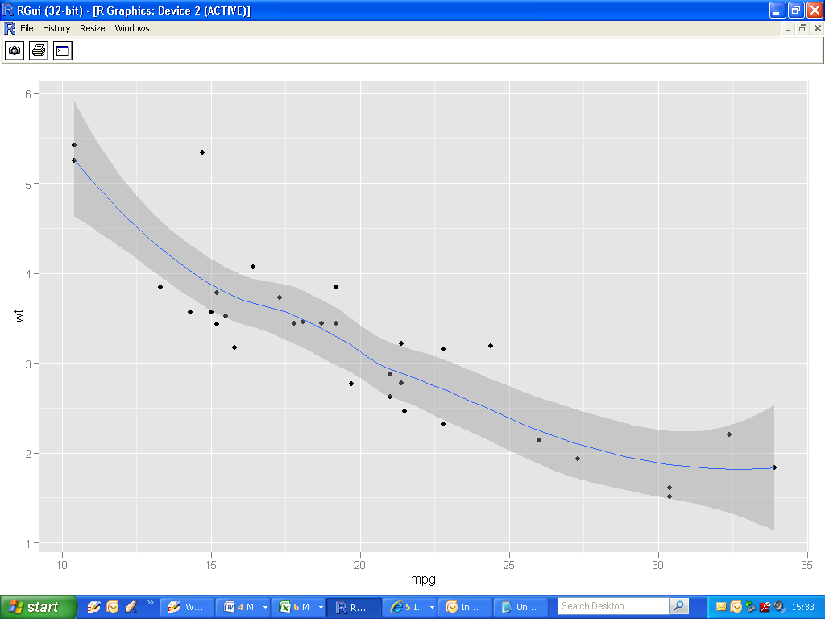

**Warning Message**

|  |
| --- |
| geom_smooth: method="auto" and size of largest group is <1000, so using loess. Use 'method = x' to change the smoothing method. |

**Additional Example (using faceting)**

|  |
| --- |
| >  >qplot(mpg,wt,data=mtcars, facets = .~am)  +geom_smooth()  > |

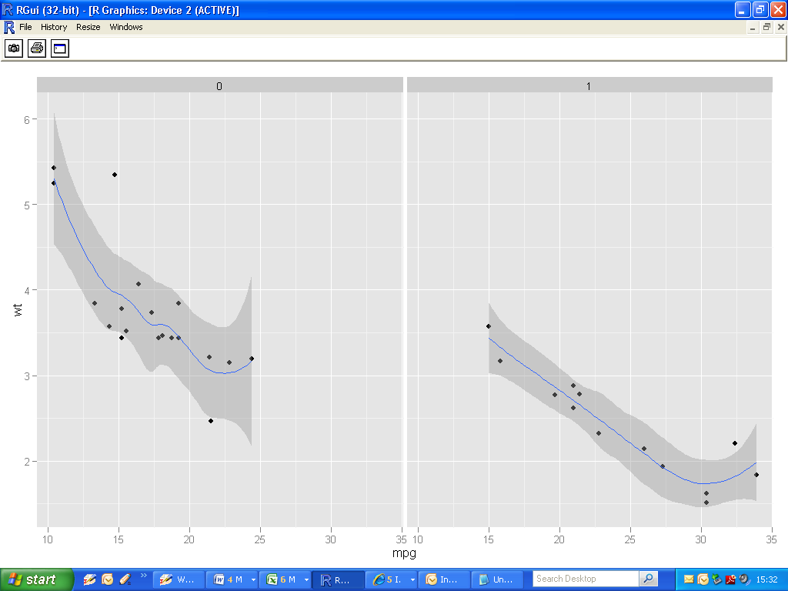

(Notice the range of x-values on both subplots are the same)

**Using ggplot()**

* Start off in similar manner to qplot().
* The function ggplot()only creates a data object. Let us call it P.
* There is no graphic yet. Try out summary() on the object.
* Add layers to the data object to build up plot.
* We specify the data set and using the aes argument, the variables and a subcategorization by cylinder.

|  |
| --- |
| P = ggplot(mtcars, aes(mpg, wt, colour=factor(cyl)))  summary(P) |

Summary output of P

|  |
| --- |
| data: mpg, cyl, disp, …… vs, am, gear, carb [32x11]  mapping: x = mpg, y = wt, colour = factor(cyl)  faceting: facet_null() |

**Add the first layer**

* Both of the following commands are equivalent.

|  |
| --- |
| >P + geom_point()  >P + layer(geom="point") |

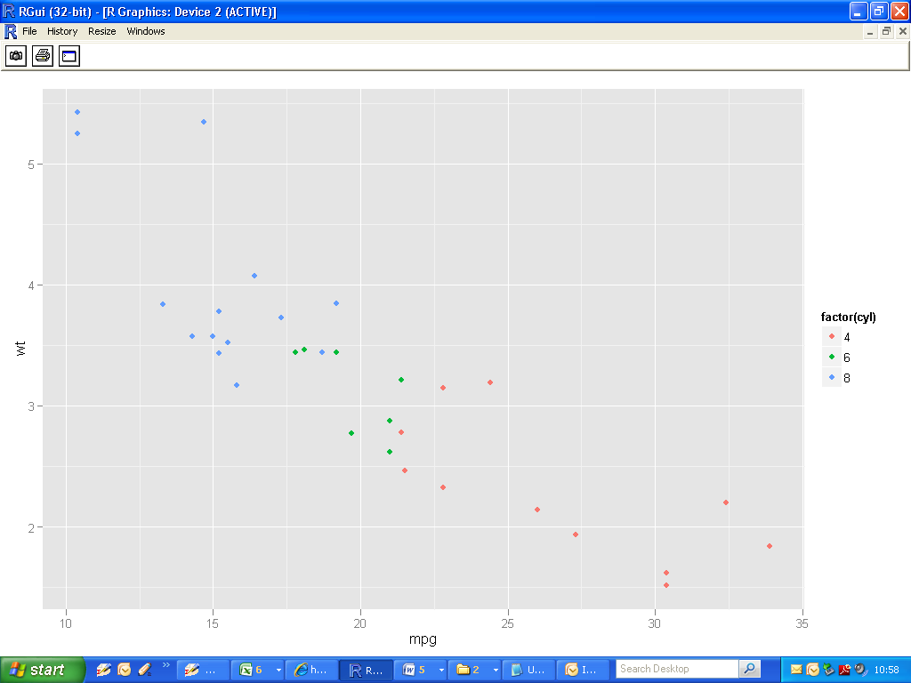

**Add a second layer**

Lets join the dots ( probably not useful in this particular case)

|  |
| --- |
| >P + geom_point()+ geom_line()  >P + layer(geom="point") + layer(geom="line") |

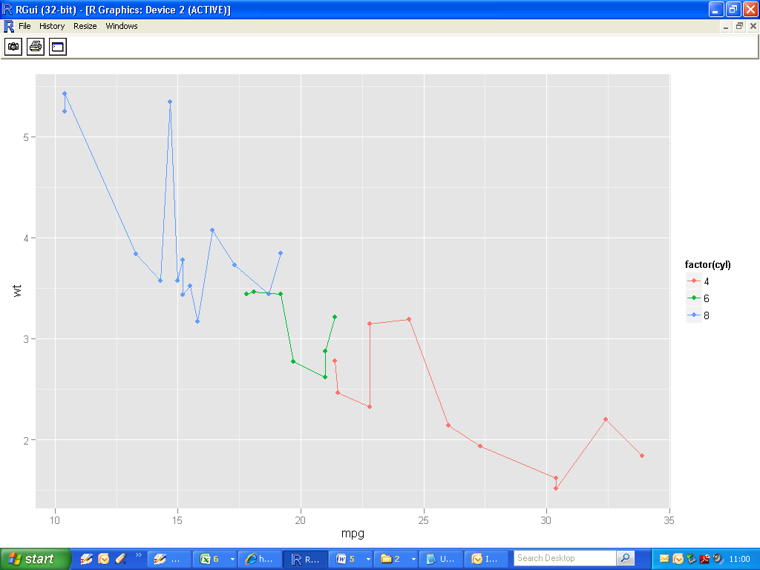

**Linear Regression ( entire data set )**

* Let’s use two different variables, with no sub-setting.
* Apply a simple linear regression model fit to the data.

|  |
| --- |
| > ggplot(mpg,aes(displ,hwy))  + geom_point()  + geom_smooth(method="lm") |

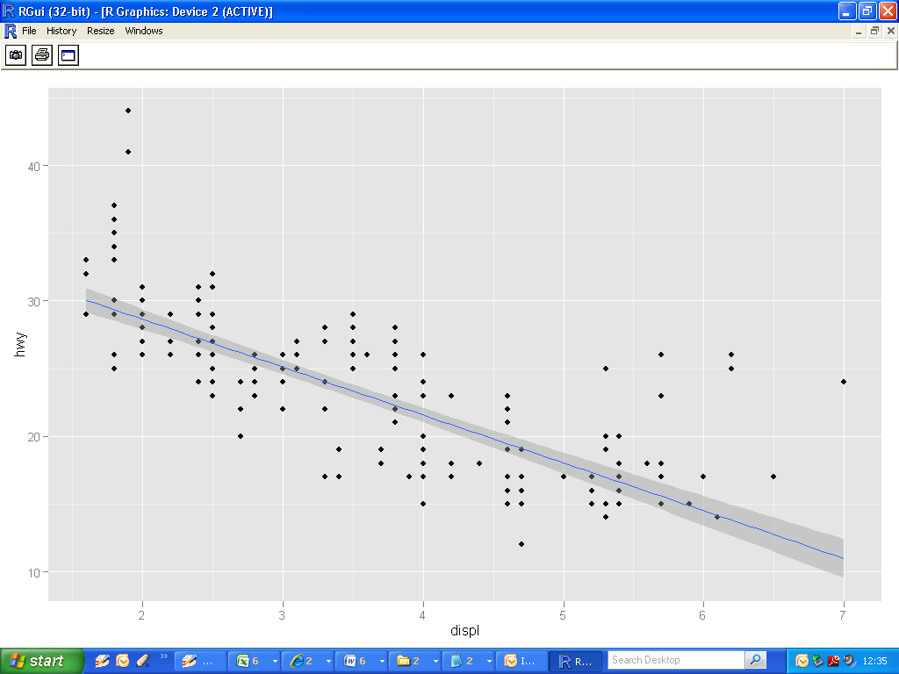

**Linear Regression ( using grouping )**

Use a *stat* instead of *geom* (equivalent) in this case.

|  |
| --- |
| > ggplot(mpg,aes(displ,hwy,colour=factor(cyl)))  + geom_point()  + stat_smooth(method="lm") |

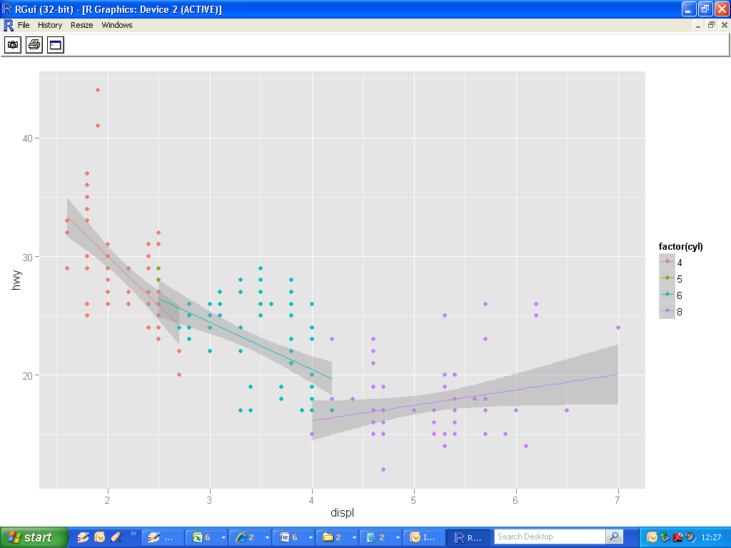

**Linear Regression ( using faceting )**

|  |
| --- |
| > P = ggplot(mpg,aes(displ,hwy))+ geom_point()  + stat_smooth(method="lm")  > P+ facet_grid(.~cyl) |

* facet_grid(cyl ~ .)
* More or less the same graph, but on top of each other.
* Can adjust scales!

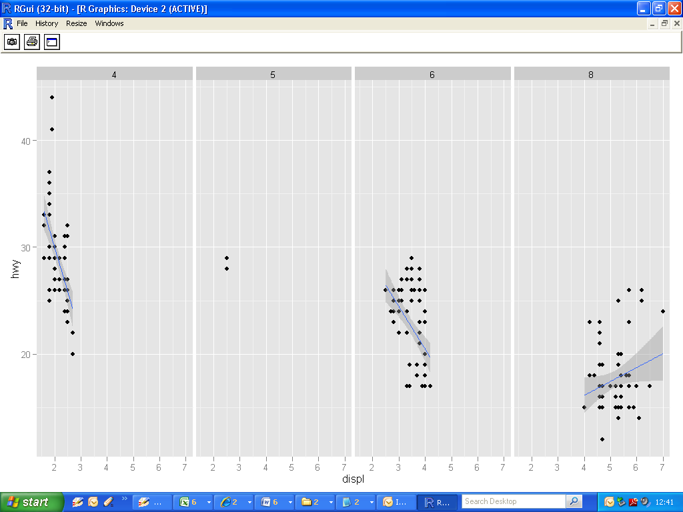**Add an additional layer with different mapping**

|  |
| --- |
| P + geom_point() + geom_point(aes(y=disp),colour="darkblue") |

* Strange plot: Faceting is useful for situations like this

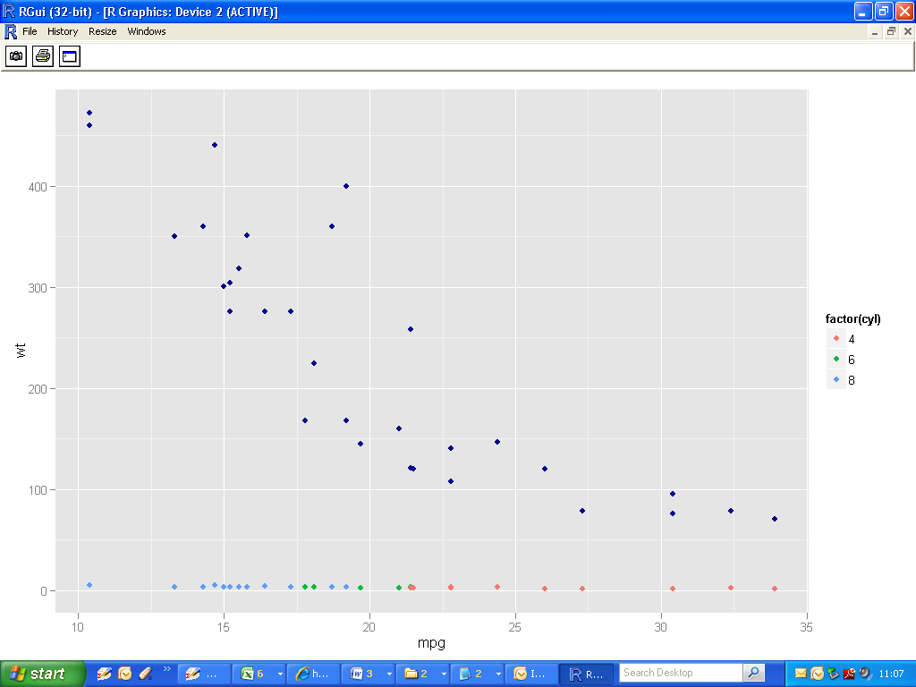

**Adding statistics to your plot**

|  |
| --- |
| >  >qplot(mpg,wt,data=mtcars)+**stat_smooth()**  > |

* Same plot as before.
* stat_smooth() equivalent to geom_smooth() and geom_ribbon() by default
* Use different geoms: Points and Error bars(probably bad idea)

|  |
| --- |
| >  >qplot(mpg,wt,data=mtcars)+  **stat_smooth(geom="point") + stat_smooth(geom="errorbar")**  > |

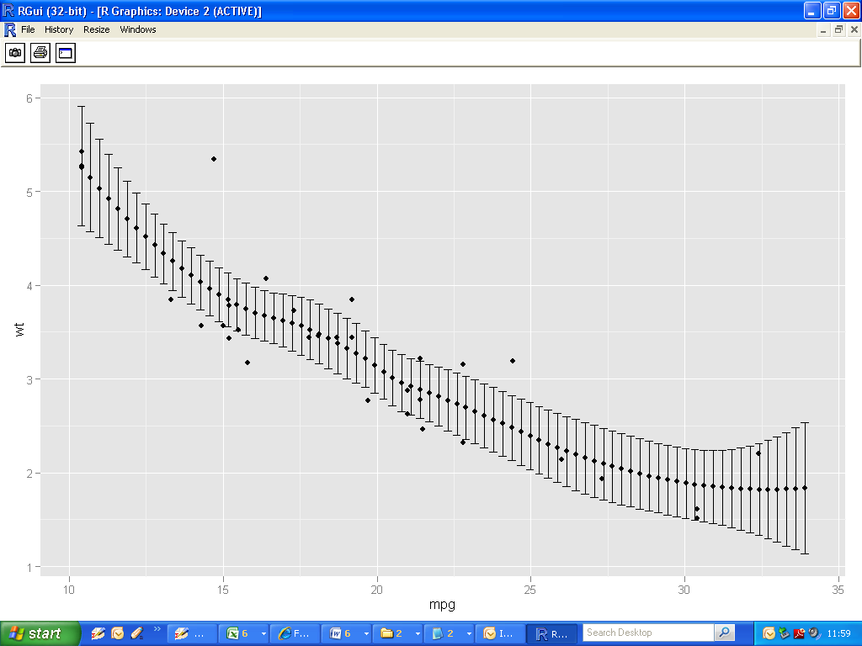**Geoms and Stats**

* Geoms always have default statistics associated with them.
* Stats always have default geoms associated with them.
* Many are interchangeable (e.g. smooth and boxplot)

**Boxplots**

|  |
| --- |
| >ggplot(mpg,aes(class,hwy))+ **stat**_boxplot()  > ggplot(mpg,aes(class,hwy))+ **geom**_boxplot()  > |

